PROJECT REPORT

HOUSE PRICE PREDICTION USING MACHINE LEARNING

Submitted as part of Data Science Internship
at Intrnforte

Submitted by:
Keerthana Sivanandan
Submission date:
5.09.2026

ACKNOWLEDGEMENT
I would like to express my sincere gratitude to IntrnForte for providing me with the opportunity to undertake this Data Science Internship.This internship has provided me with valuable practical exposure to machine learnig concepts and real-world data analysis.
I am deeply thankful to my internship mentors and the IntrnForte team for their guidance, and support throughout the training.Their valuable learning resources greatly enhanced my understanding of data preprocessing, exploratory data analysis, machine learning algorithms, and model evaluation.

ABSTRACT
House price prediction is one of the most important applications of machine learning in the real estate sector.Accurate prediction of house prices helps buyers , sellers, investors, and real estate agencies ,ake infor,ed decisions. The primary objective of this project is to develop a machine learning model capable of predicting house prices based on various property features such as overall quanlity, living area, garage capacity, basement area, year built,and other housing attributes.
The project uses the House Prices:Advanced Regression Techniques dataset obtained from Kaggle. Initially, the dataset was preprocessed by handling missing values, removing unnecessary columns, and converting categorical variables into numerical format using one=hot encoding.Exploratory Data Analysis(EDA) was performed to understand the distribution of variables, identify outliers, and analyse the relationships between different features using various visualization techniques.
Three machine learning algorithms-Linear Regression, Decision Tree Regressor, and Random Forest Regressor-were implemented and trained using the processed dataset. The performance of each model was evaluated using Mean Absolute Error(MAE),Root Mean Squared Error(RMSE), and R² Score. Among three models, the Random Forest Regressor achieved the best performance with an R² Score of 0.8913, demontrating its ability to accurately predict house prices.
The results indicate that ensemble learning techniques such as Random Forest provide better prediction accuracy compared to individual regression models. This project demonstratesthe effectiveness of machine learning in solving real-world regression problems and highlights its potential applications in the real estate industry for property valuation and decision-making.
TABLE OF CONTENTS

S.NO. | Contents | Page No.
1 | Acknowledgement | ii
2 | Abstract | iii
3 | Table of Contents | iv
4 | Introduction | 1
5 | Problem Statement | 2
6 | Objecives | 2
7 | Dataset Description | 5
8 | Methadology | 10
9 | Data Preprocessing | 11
10 | Exploratory Data Analysis | 12
11 | Model Building | 16
12 | Model Evaluation | 18
13 | Results and Discussions | 18
14 | Conclusions | 21
15 | Future Scope | 22
16 | References | 23

CHAPTER 1
1.1 INTRODUCTION
Machine learning is a branch of Artificial Intelligence that enables computers to learn patterns from historical data and make prdictions without being explicitily programmed.It is widely used in domains such as healthcare, finance, education, agriculture, and real estate is house price prediction.
House price prediction is the process of estimating the selling price of a house based on various features, including the size of the house,location, overall quality, number of bedrooms, garage capacity, basement area, year of construction, and several other factors. Accurate prediction of house prices helps buyers, sellers, investors, and real estate companies make informed decisions and determine fair property values.
In this project, the House Prices:Advancd Regression Techniques dataset is used to develop a predictive model. The dataset contains various attributes describing residential properties and their corresponding sale prices. Before building the model,the dataset is preprocessed by handling missing values, encoding categorical variables, and performing Exploratory Data Analysis(EDA) to understand the characteristics of the data.
Three machine learning algorithms-Linear Regression, Decision Tree Regressor,and Random Forest Regressor-are implemented and compared.Their performance is evaluated using Mean Absolute error(MAE), Root Mean Squared Error(RMSE) and R² Score. Based on the evaluation results, the Random Forest Regressor achieved the best prediction accuracy and was selected as the final model.
This project demonstrates how machine learning techniques can effectively solve real-world regression problems and support data-driven decision-making in the real estate industry.

1.2 PROBLEM STATEMENT
Estimating the market value of a house is a complex task because it depends on multiple factors such as location, property size, construction quality, age of the building, garage capacity, and neighbourhood characteristics. Traditional pricing methods often rely on manual estimation, which can be subjective and inconsistent.
The objective of this project is to develop a machine learning model that accurately predicts house prices based on property features. The model should analyse historical housing data, learn the relationship between different features and sale prices, and generate reliable predictions for unseen data.

1.3 OBJECTIVES
The main objectives of this project are:
- To develop a machine learning model for house price prediction.
- To preprocess the dataset by handling missing values and encoding categorical variables.
- To perform Exploratory Data Analysis(EDA) to understand the data.
- To identify the important features that influence house prices.
- To train multiple machine learning models for regression.
- To compare the performance of different regression algorithms.
- To evaluate the models using MAE, RMSE, and R² Score.
- To identify the best-performing model for predicting house prices.

1.4 SCOPE OF PROJECT
The scope of this project includes developing a machine learning-based system for predicting residential house prices using historical housing data. The project demonstrates the complete workflow of a regression problem, including data preprocessing, visualisation, feature engineering, model training and evaluation. The developed model can assist buyers, sellers, and real estate professionals in estimating property values more accurately and can be extended for use in real-world real estate applications.

.CHAPTER 2
DATASET DESCRIPTION
2.1 Dataset Overview
The dataset used in the project is the House Prices: Advanced
Regression Techniques dataset obtained from Kaggle. It is a widely used
dataset for regression problems and contains detailed information about
residential houses. The objective of the dataset is to predict the selling price of a
house based on various physical and structural characteristics.
The dataset consists of two files:
- train.csv – used to train the machine learning models. It contains both the input features and the target variable(SalePrice).
- test.csv – used to test the trained model and generate predictions. This file does not contain the SalePrice column.
Additionally, the dataset includes a data_description.txt file that provides detailed explanations of all features present in the dataset.

2.2 Dataset Information
Attribute | Description
Dataset Name | House Prices:Advanced Regression Techniques
Source | Kaggle
Problem Type | Regression
Training Records | 1460
Test Records | 1459
Number of Features | 79(excluding target variable)
Target Variable | SalePrice

2.3 Target Variable
The target variable in this project is SalePrice.
SalePrice represents the final selling price of each house in US dollars. The
primary objective of this project is to predict the value of the SalePrice column
using the remaining features in the dataset.

2.4 Important Features
Although the dataset contains many attributes, some of the most influential
Features identified during analysis include:
Feature | Description
OverallQual | Overall quantity of the house
GrLivArea | Above-ground living area
GarageCars | Garage capacity(number of cars)
GarageArea | Garage size in square feet
TotalBsmtSF | Total basement area
1stFlrSF | First floor area
FullBath | Number of full bathrooms
YearBuilt | Year the house was built
YearRemodAdd | Year of the last remodelling
LotArea | Total lot size

These features significantly influence the selling price and play an important
role in building an accurate prediction model.

2.5 Dataset Challenges
Before training the machine learning models, several challenges in the
dataset were addressed:
- Missing values in numerical and categorical columns.
- Categorical variables that required encoding into numerical values.
- Presence of outliers affecting model performance.
- Different feature scales and distributions.
- High number of input features requiring preprocessing.
These issues were resolved during the data preprocessing stage to improve the performance and reliability of the machine learning models.

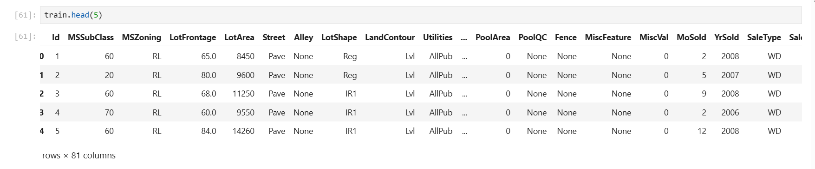
Figure 1:Preview of the House Prices training dataset using train.head()

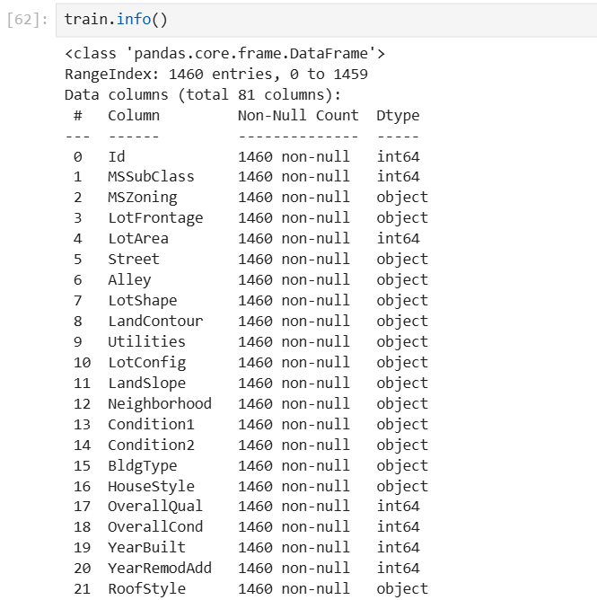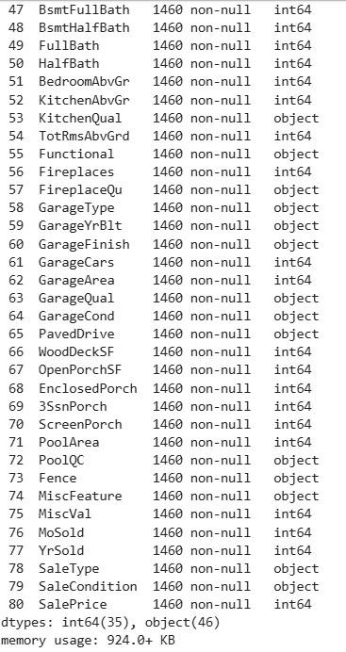
Figure 2: Dataset Information Obtained using train.info()

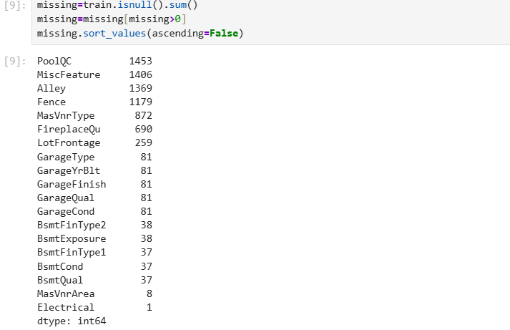

Figure 3:Missing Values Analysis of the House Prices Dataset

CHAPTER 3
METHADOLOGY
3.1 Overview
The methodology describes the sequence of steps followed to build the house price prediction model. The project started with collecting the dataset, followed by data preprocessing, exploratory data analysis, feature engineering, model training, and performance evaluation. The complete workflow is illustrated through the following stages.
3.2 Workflow
The methodology adopted for this project consists of the following steps:
1. Data collection
2. Data Loading
3. Data Preprocessing
4. Exploratory Data Analysis
5. Feature Engineering
6. Data Splitting
7. Model Building
8. Model Evaluation
9. Feature Importance Analysis

3.3 Data Collection
The dataset used for this project was obtained from Kaggle House Prices: Advanced Regression Techniques competition. It consists of training and testing datasets containing various features related to residential properties. The train.csv file was used to train the machine learning models, while the test.csv file was reserved for prediction.

3.4 Data Loading
The dataset was loaded into Python using the Pandas library. The first few records were displayed using the head() function, and the structure of the dataset was examined using the info() function.
Figure 1:Preview of dataset using train.head()
Figure 2:Dataset information obtained using train.info()

3.5 Data Preprocessing
Data Preprocessing was performed to improve the quality of the dataset before model training. The following operations were carried out:
- Identification of missing values.
- Filling missing numerical values using the median.
- Filling missing categorical values using the mode of “None” where appropriate.
- Removal of unnecessary columns, if required.
- Conversion of categorical variables into numerical form using One-Hot Encoding.
Figure 3:Missing Values Analysis

3.6 Exploratory Data Analysis
Exploratory Data Analysis was performed to understand the characteristics of the dataset. Various visualisation techniques were used to study the distribution of variables, relationships between features, and the target variable.
The following analyses were performed:
- Distribution of house prices.
- Correlation analysis.
- Box plots for outlier detection.
- Histograms for numerical features.
- Count plots for categorical features.

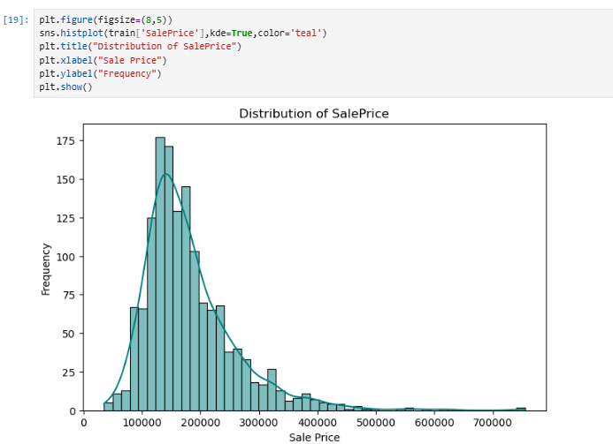
Figure 4: Distribution of the Target Variable(SalePrice)

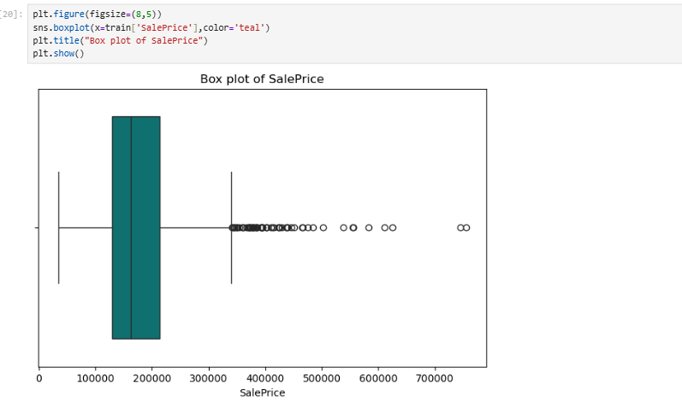
Figure 5:Box Plot for Outlier Detection
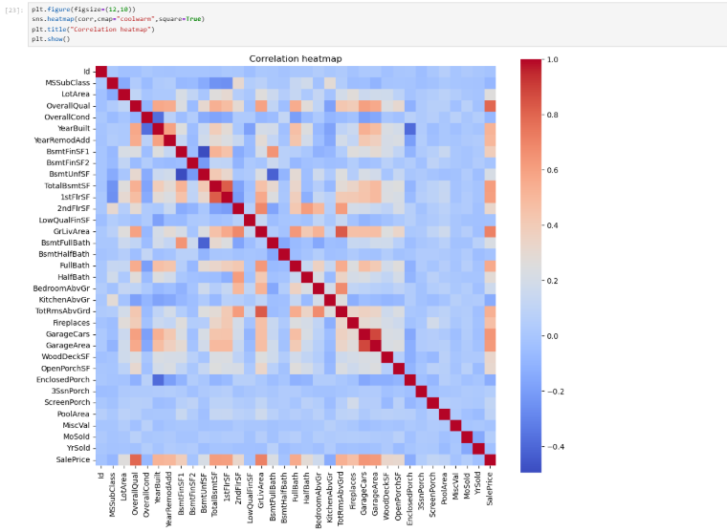
Figure 6:Correlation Heatmap

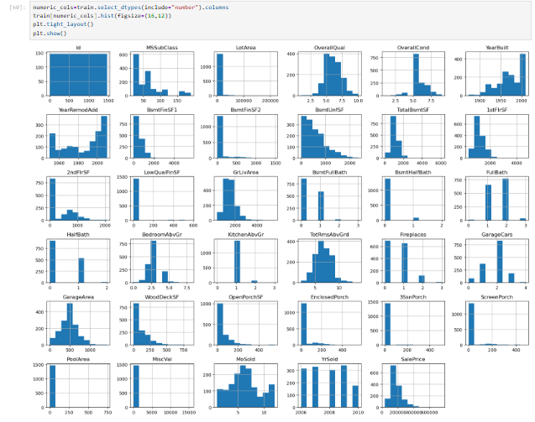

Figure 7:Histogram of numeric features

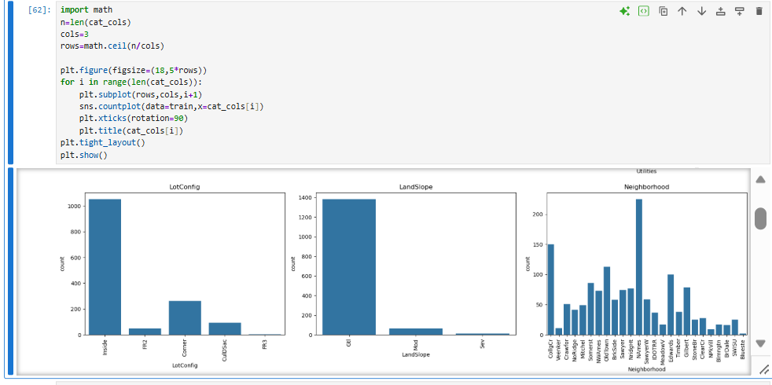
Figure 8:Count plot of Categorical Features

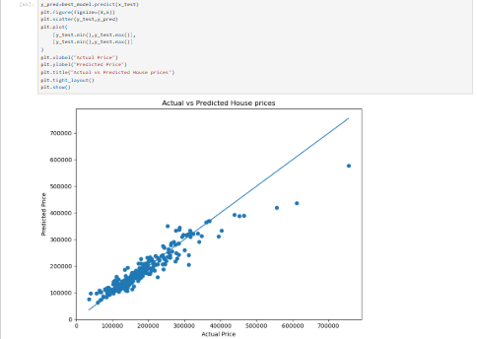
Figure 9:Actual vs Predicted prices
CHAPTER 4
MODEL DEVELOPMENT
4.1 Data preparation for Model Training
After completing Exploratory Data Analysis, the dataset was prepared for machine learning. The target variable, SalePrice, was separated from the input features.
The dataset was divided into:
X-independently/input features
y-dependent/target variable(SalePrice)
Categorical variables were converted into numerical representations using One-Hot Encoding, allowing them to be processed by the machine-learning algorithms.
4.2 Train Test Split
The processed dataset was divided into training and testing subsets using the train_test_split() function.
The training data was used to build the models, while the testing data was used to evaluate their performance on previously unseen observations.
4.3 Machine Learning Models
Three regression algorithms were implemented for house price prediction:
4.3.1 Linear Regression
Linear Regression was used as a baseline regression model. It attempts to establish a linear relationship between the input features and the house price
4.3.2 Decision Tree Regressor
Decision Tree Regression predicts house prices by dividing the data into smaller groups based on feature values. It can capture non-linear relationships between the features and the target variable.
4.3.3 Random Forest Regressor
Random Forest Regression combines predictions from multiple decision trees. This generally provides better stability and reduces the risk of overfitting compared with a single decision tree.
4.4 Model Evaluation
The models were evaluated using three metrics:
Mean Absolute Error(MAE):
MAE measures the average absolute difference between the actual and predicted prices.
Lower MAE gives better performance
Root Mean Squared Error(RMSE):
RMSE measures the square root of the average squared prediction error. Because large errors are penalised more heavily, RMSE is useful for identifying models that make large prediction errors.
Lower RMSE gives better performance
R² Score:
R² indicates how much of the variation in house prices is explained by the model.
Higher R² gives better performance.
4.5 Model Performance
The performance of the implemented regression models was evaluated using Mean Absolute Error (MAE), Root Mean Squared Error (RMSE), and R² Score. These metrics were used to compare the prediction accuracy of Linear Regression, Decision Tree Regression, and Random Forest Regression.
4.5.1 Model Comparison
Model | MAE | RMSE | R² SCORE
Linear Regression | 27102.18 | 39360.79 | 0.7980
Decision Tree Regressor | 26267.45 | 39713.02 | 0.7944
Random Forest Regressor | 17777.58 | 28869.99 | 0.8913

4.5.2 Results and Discussion
The performance of the three regression models was compared. The Linear Regression model achieved an R² Score of 0.7980, while the Decision Tree Regressor achieved an R² Score of 0.7944. The Random Forest Regressor performed better than both models, achieving the highest R² Score of 0.8913.
The Random Forest Regressor also obtained the lowest MAE of 17777.58 and the lowest RMSE of 28869.99.Lower MAE and RMSE values indicate smaller prediction errors. Therefore, based on the evaluation metrics, the Random Forest Regressor was selected as the best-performing model or house price prediction.
The R² Score of 0.8913 indicates that the model explains approximately 89.13% of the variation in the house prices in the test dataset.
4.6 Actual vs Predicted House Prices
Figure 9:Actual vs Predicted House Prices using Random Forest Regressor
The actual versus predicted plot compares the actual house prices with the prices predicted by the Random Forest Regressor. Points closer to the diagonal reference line indicate more accurate predictions. The plot shows that the Random Forest model captures the general relationship between the input features and house prices, although some differences between actual and predicted values can be observed.

4.7 Feature Importance Analysis
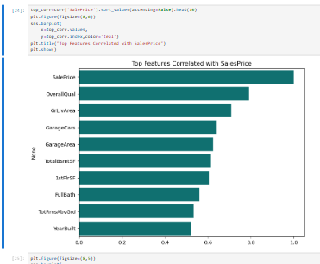

Figure 10:Top 10 Important Features for House Price Prediction
Feature Importance analysis was performed using the Random Forest Regressor to identify the features that contributed most to the prediction of house prices. Features with higher importance values have a greater influence on the models predictions. This analysis helps in understanding which property characteristics are most relevant to house price prediction.

CHAPTER 5
CONCLUSION AND FUTURE SCOPE
5.1 Conclusion
This project focused on developing a machine learning-based house price prediction system using the House Prices dataset. The project involved data preprocessing, exploratory data analysis, feature preparation, model development, and performance evaluation.
Exploratory Data Analysis was performed to understand the distribution of numerical and categorical features, identify relationships between variables, and examine important patterns in the dataset. The data was then prepared for machine learning by handling missing values and converting categorical
variables into a suitable numerical format.
Three regression models, namely Linear Regression, Decision Tree Regression, and Random Forest Regression, were implemented and evaluated using Mean Absolute Error(MAE), Root Mean Squared Error(RMSE), and R² Score.
Among the three models, the Random Forest Regressor performed the best, achieving R² Score of 0.8913, MAE of 17777.58, and RMSE of 28869.99. Therefore, the Random Forest Regressor was selected as the best-performing model for this project.
The project demonstrates how machine learning techniques can be applied to real-world regression problems such as house price prediction. The analysis also showed that different property-related features contribute differently to the prediction of house prices.
5.2 Future Scope
The project can be further improved by applying advanced machine learning and optimization techniques. Hyperparameter tuning can be performed to improve the performance of the Random Forest model. Other advanced regression algorithms such as Gradient Boosting, XGBoost, or LightGBM can also be explored.
Additional feature engineering can be performed to create more meaningful variables from the existing dataset. Cross-validation can be used to obtain a more reliable estimate of model performance. The trained model can also be deployed as a web-based application where users can enter details properly and obtain an estimated house price.
In the future, the system could also be enhanced by incorporating real-time housing market data, location-based information, and additional economic factors to improve prediction accuracy.

REFERENCES

- Kaggle. House Prices- Advanced Regression Techniques. Kaggle.
- Python Software Foundation. Python Documentation. Python Software Foundation.
- pandas. Pandas Documentation.
Documentation for data manipulation and analysis
- scikit-learn. Scikit-learn Documentation.
Documentation for machine learning algorithms and evaluation metrics.
- Matplotlib. Matplotlib Documentation.
Documentation for data visualization.
- Seaborn. Seaborn Documentation.
Documentation for statistical data visualization

